Assignment after first week

1. Print the following pattern

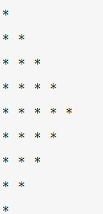

1. Take, n float numbers as an input from the user, the find the average.
2. Count all lower case, upper case, digits, and special symbols from a given string.
3. Generate 100 random lottery tickets and pick two lucky tickets from it as a winner.

* The lottery number must be 10 digits long.
* All 100 ticket number must be unique.

1. Made a SEO friendly url from a topic name.

Input “A notes on Special theory of Relativity”

Output: <https://example.com/a-notes-on-special-theory-of-relativity>

1. Write a Python program to convert a given dictionary into a list of lists.

Original Dictionary:

{1: 'red', 2: 'green', 3: 'black', 4: 'white', 5: 'black'}

Convert the said dictionary into a list of lists:

[[1, 'red'], [2, 'green'], [3, 'black'], [4, 'white'], [5, 'black']]

Original Dictionary:

{'1': 'Austin Little', '2': 'Natasha Howard', '3': 'Alfred Mullins', '4': 'Jamie Rowe'}

Convert the said dictionary into a list of lists:

[['1', 'Austin Little'], ['2', 'Natasha Howard'], ['3', 'Alfred Mullins'], ['4', 'Jamie Rowe']]